# Unit 9 - Risk Assessment



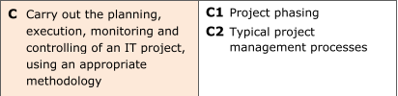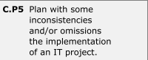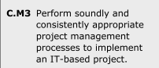

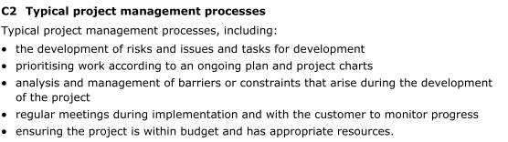

# 

# Risk Assessment - central

|  |  |  |  |  |
| --- | --- | --- | --- | --- |
| **Barriers & Risks that could cause overrun on time or halt progress** | **Likelihood Score (1-Low, 2-Medium, 3-High)** | **Impact Score (1-Low, 2-Medium, 3-High)** | **Risk Score (Likelihood X Impact) (1 to 3 = Low, 4 to 6 = Medium, 7-9 = High)** | **Control Measures (What are you going to do on top of your normal routine to reduce the likelihood of the Risk Occurring?)** |
| **Work** | 2 | 3 | Medium | Reduce my working hours using my availability |
| **Other college workload** | 3 | 2 | Medium | Organize my time better. |
| **Ability to make a website that is aesthetically pleasing.** | 1 | 1 | Low | Although being somewhat proficient in my ability to program in HTML, I need to practice some more CSS and JavaScript. |
| **Low energy** | 3 | 2 | Medium | Organize my time better allowing me to sleep better. |
| **Skills using photo editing software** | 3 | 3 | High | Practice using this software. |
| **Reliability of college computers** | 2 | 3 | Medium | Make sure I am managing my workload at home so that if something like this |
| **Reliability of Personal computer** | 1 | 1 | Low | Keep buying parts to upgrade. Make sure that my PC is organized and optimized well enough to prevent it causing any issues. |
| **Travel time** | 2 | 3 | Medium | Leave earlier in order to reach my destination on time or early. |
| **Well being** | 1 | 3 | Low | Make sure I continue my work even if I am too ill to travel. |

# Risk Assessment - idea 1

|  |  |  |  |  |
| --- | --- | --- | --- | --- |
| **Barriers & Risks that could cause overrun on time or halt progress** | **Likelihood Score (1-Low, 2-Medium, 3-High)** | **Impact Score (1-Low, 2-Medium, 3-High)** | **Risk Score (Likelihood X Impact) (1 to 3 = Low, 4 to 6 = Medium, 7-9 = High)** | **Control Measures (What are you going to do on top of your normal routine to reduce the likelihood of the Risk Occurring?)** |
| **Procrastination for the design** | 2 | 3 | Medium | Make sure that no changes are made unless they are vital. |
| **Finding images to fit gaps** | 3 | 2 | Medium | Make sure that the images are good resolutions and that I can program them into the website. |
| **Keeping whitespace and managing it appropriately** | 2 | 3 | Medium | This design doesn’t have very good whitespace so creating some will be a little bit of an issue since it will change the look of the website. |
| **Programming the site** | 1 | 1 | Low | The site will be easy to make since it doesn’t require lots of code or experience as it is an easy design. |

# Risk Assessment - idea 2

|  |  |  |  |  |
| --- | --- | --- | --- | --- |
| **Barriers & Risks that could cause overrun on time or halt progress** | **Likelihood Score (1-Low, 2-Medium, 3-High)** | **Impact Score (1-Low, 2-Medium, 3-High)** | **Risk Score (Likelihood X Impact) (1 to 3 = Low, 4 to 6 = Medium, 7-9 = High)** | **Control Measures (What are you going to do on top of your normal routine to reduce the likelihood of the Risk Occurring?)** |
| **Procrastination for the design** | 2 | 3 | Medium | Make sure that no changes are made unless they are vital. |
| **Finding images to fit gaps** | 3 | 2 | Medium | Make sure that the images are good resolutions and that I can program them into the website. |
| **Keeping whitespace and managing it appropriately** | 2 | 1 | Low | This design doesn’t have very good whitespace so creating some will be a little bit of an issue since it will change the look of the website. |
| **Programming the site** | 1 | 1 | Low | The site will be easy to make since it doesn’t require lots of code or experience as it is an easy design. |

# 